NISD Programme No: 11
ONE DAY AWARENESS GENERATION PROGRAM AGAINST DRUG ABUSE
Venue: Kongu Arts & Science College, Erode.
Date: 31st October 2016
Participants: 42 Students & 2 Faculties

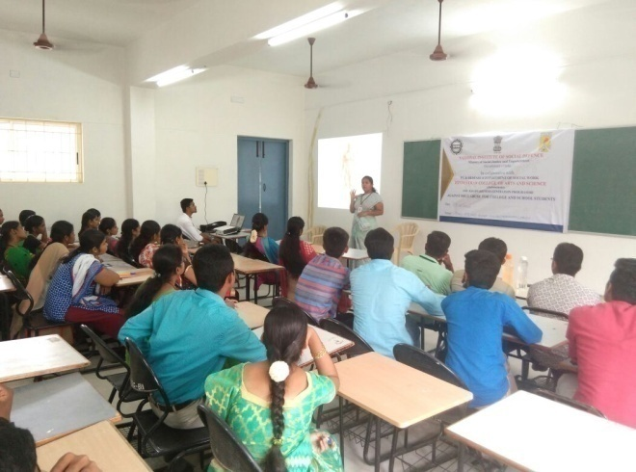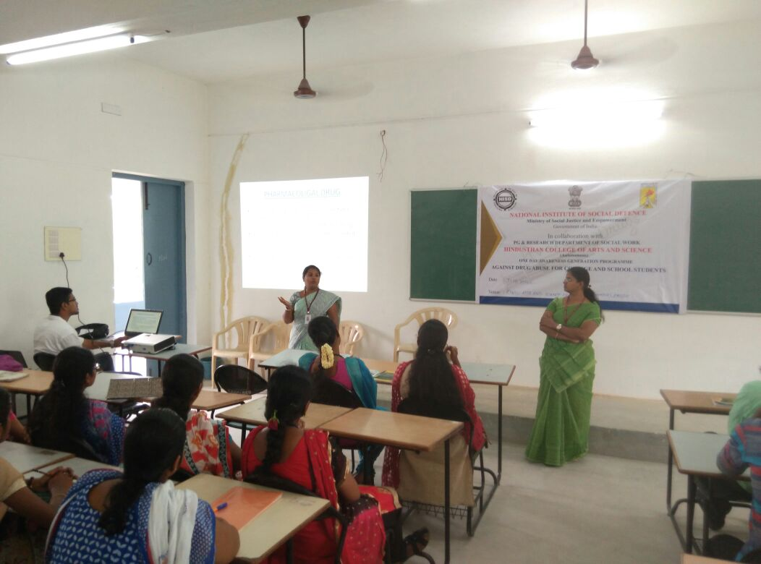
Resource person presentation on drug abuse 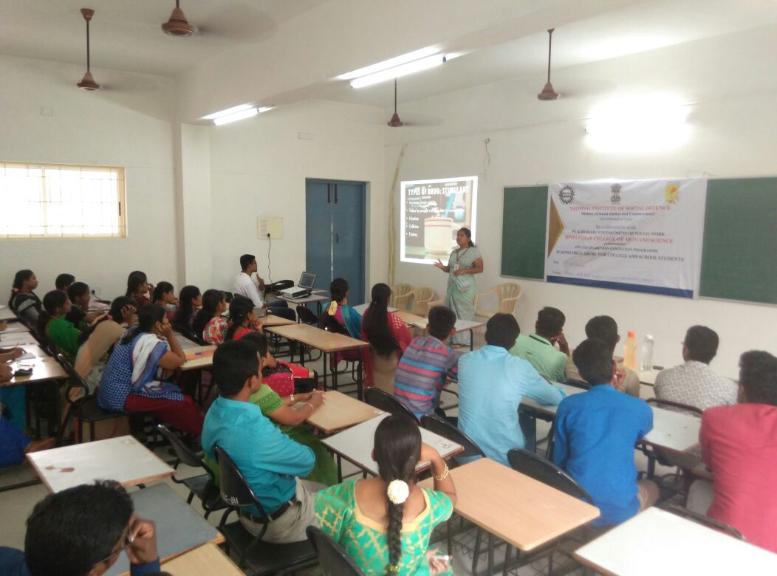
Group Discussion on drug abuse Students watching documentary film
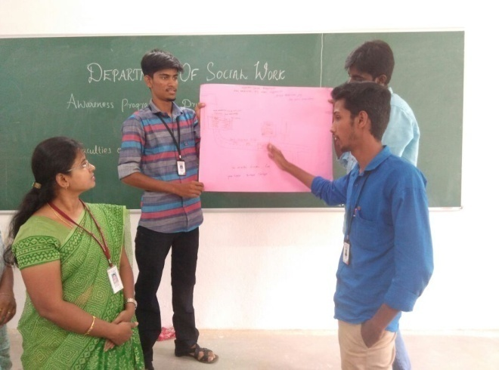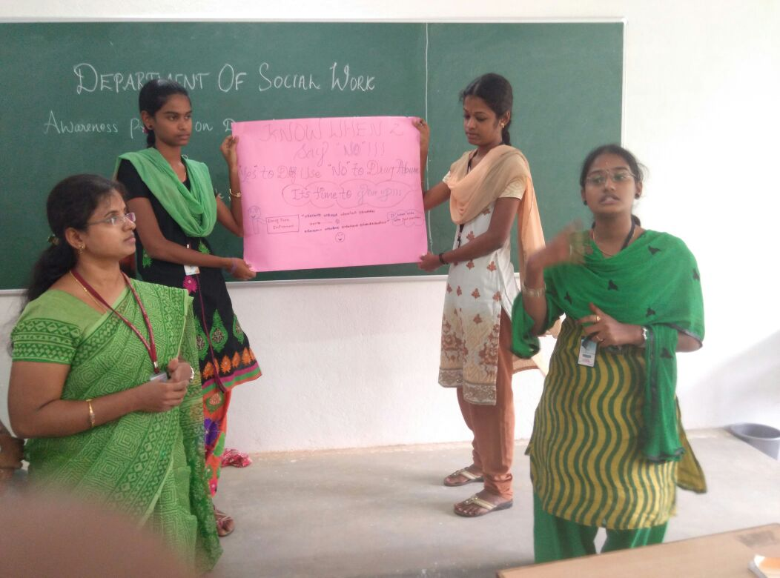
Student’s chart work presentation

NISD Programme No: 12
ONE DAY AWARENESS GENERATION PROGRAM AGAINST DRUG ABUSE
Venue: Gurukulam High School, Coimbatore.
Date: 31st October 2016
Participants: 42 Students & 2 Teachers
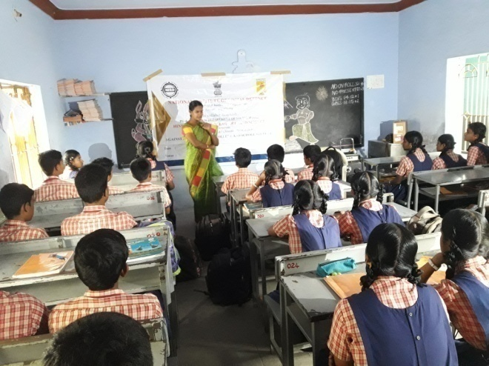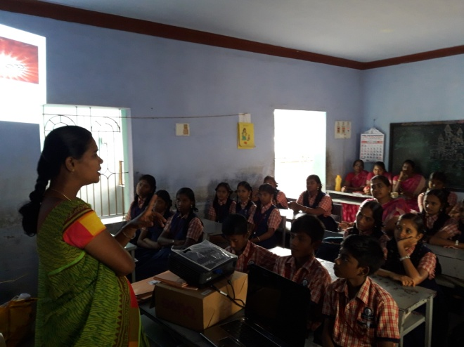
Resource person presentation on drug abuse
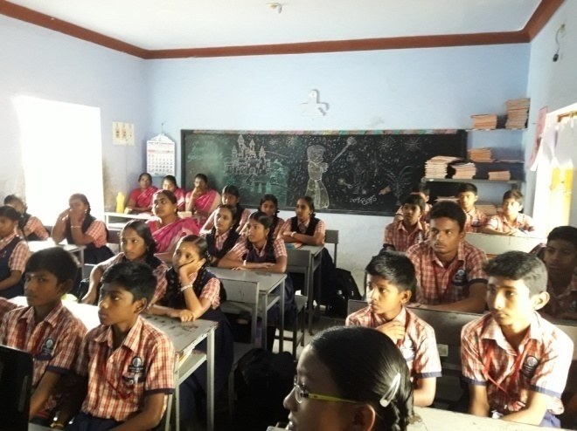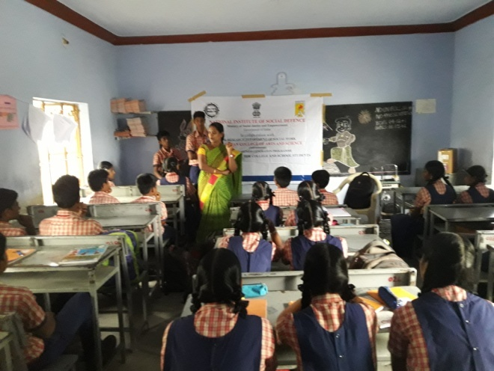
Videos on drug abuse Group Discussion on drug abuse
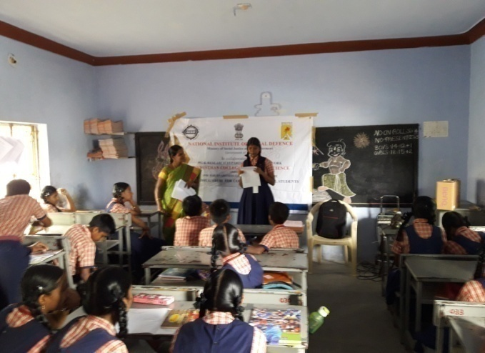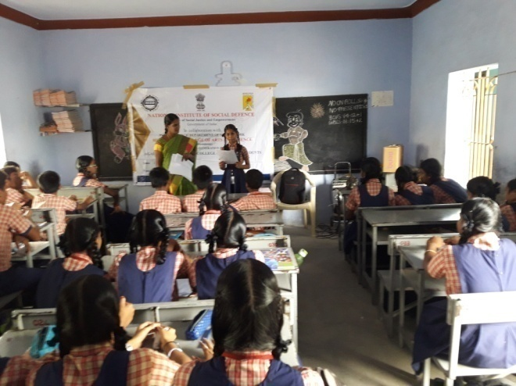
Student’s presentation on drug abuse

NISD Programme No: 13
ONE DAY AWARENESS GENERATION PROGRAM AGAINST DRUG ABUSE
Venue: Vasavi Vidyalaya Matriculation Higher Secondary School, Coimbatore.
Date: 1st November 2016
Participants: 45 Students & 2 Teachers
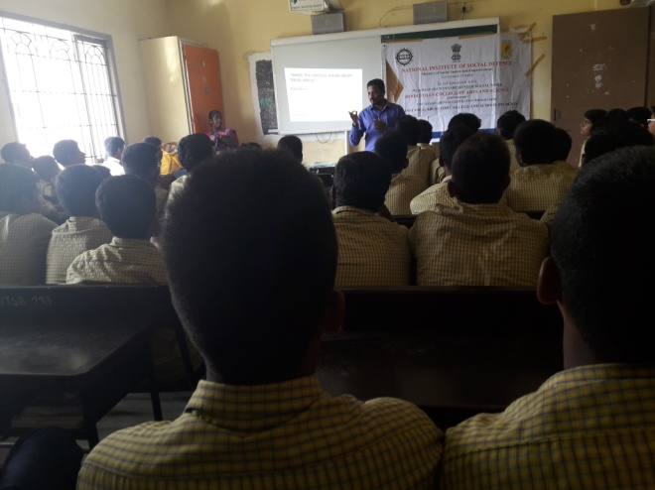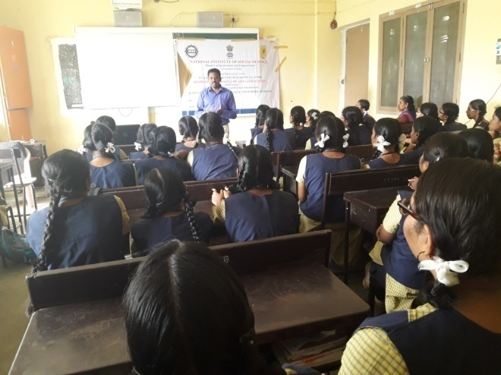
Resource person presentation on drug abuse
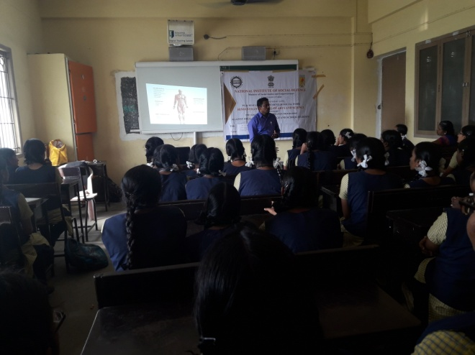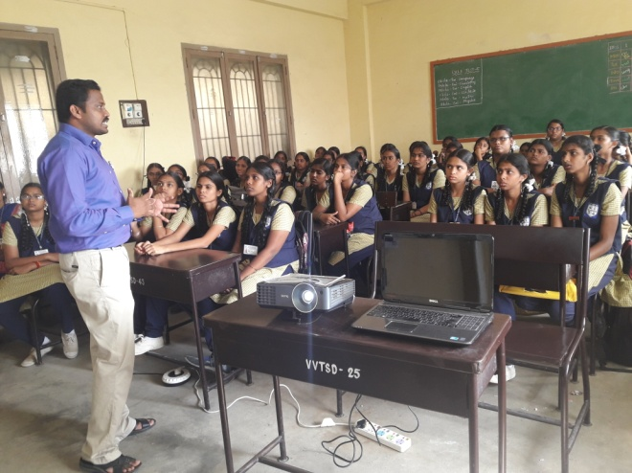
Watching documentary film on drug abuse
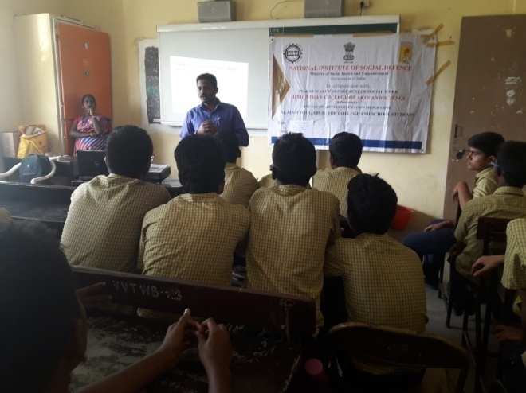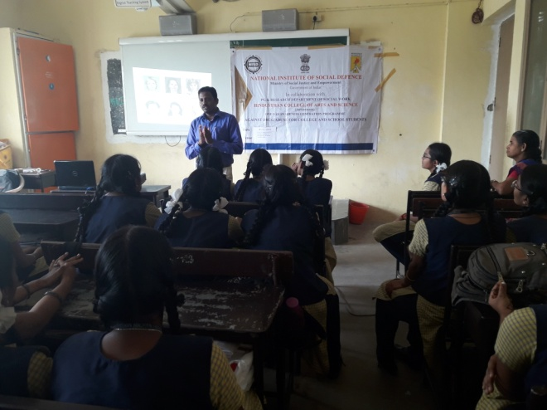
Group Discussion on drug abuse

NISD Programme No: 14
ONE DAY AWARENESS GENERATION PROGRAM AGAINST DRUG ABUSE
Venue: Gnanambikai Matriculation School, Coimbatore.
Date: 2nd November 2016
Participants: 40 Students & 2 Teachers
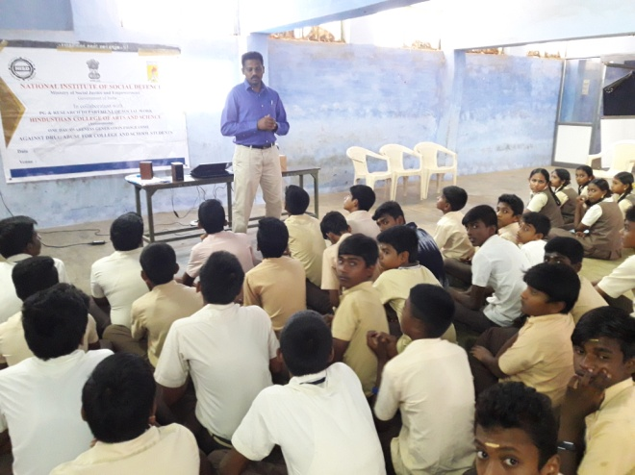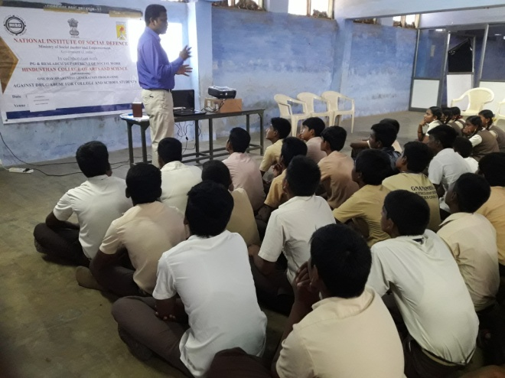
Resource person presentation on drug abuse
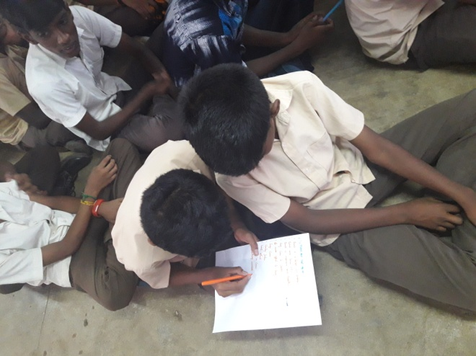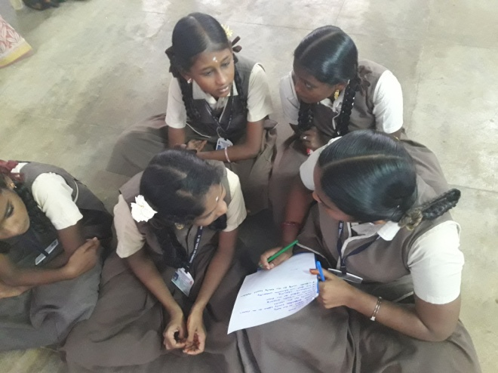
Chart work preparation for students
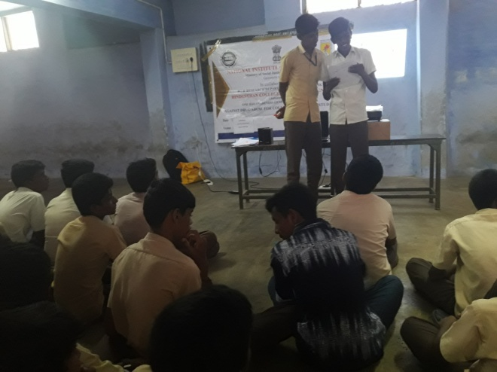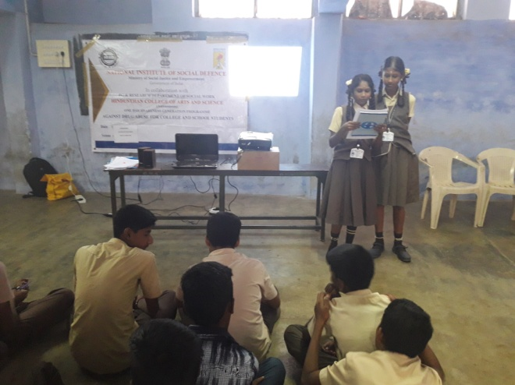
Student’s presentation on drug

NISD Programme No: 15
ONE DAY AWARENESS GENERATION PROGRAM AGAINST DRUG ABUSE
Venue: Government Higher Secondary School, Coimbatore.
Date: 3rd November 2016
Participants: 44 Students & 2 Teachers
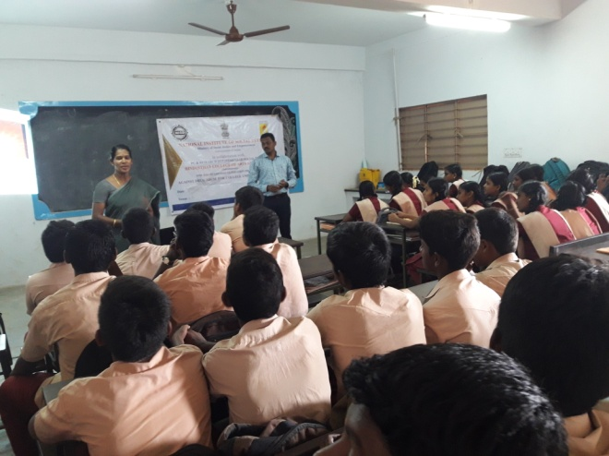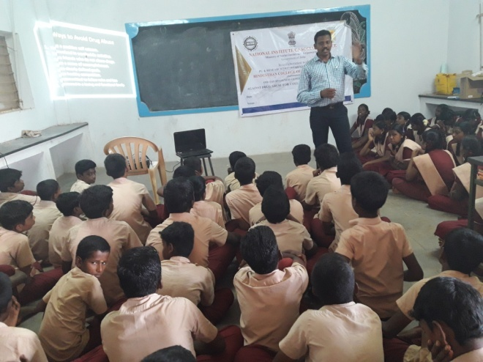
Resource person presentation on drug abuse
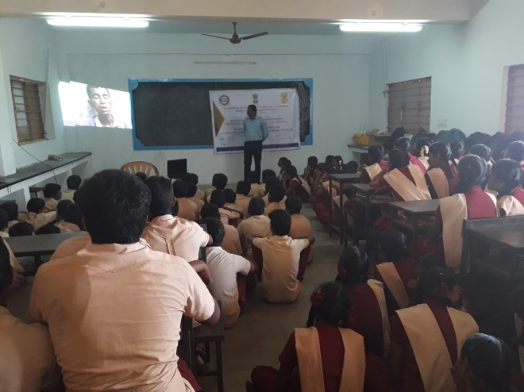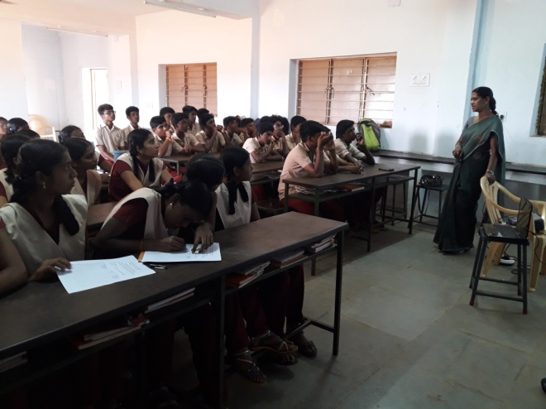
Students watching documentary film on drug abuse Chart work for students
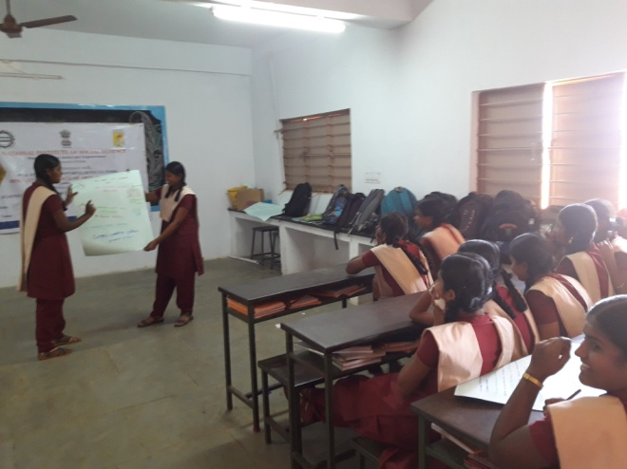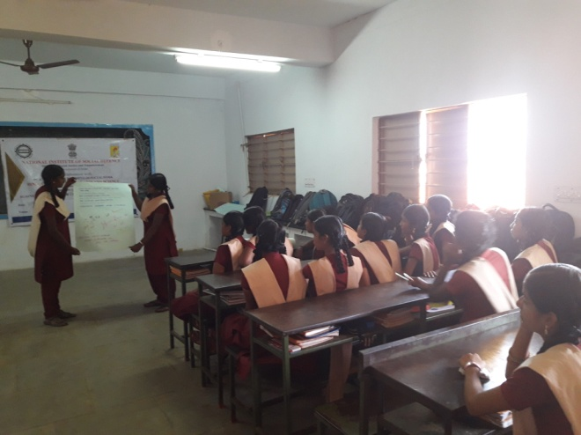
Student’s presentation on drug abuse

