HINDUSTHAN COLLEGE OF ARTS AND SCIENCE
MINUTES OF MEETING HELD ON 18.12.2018
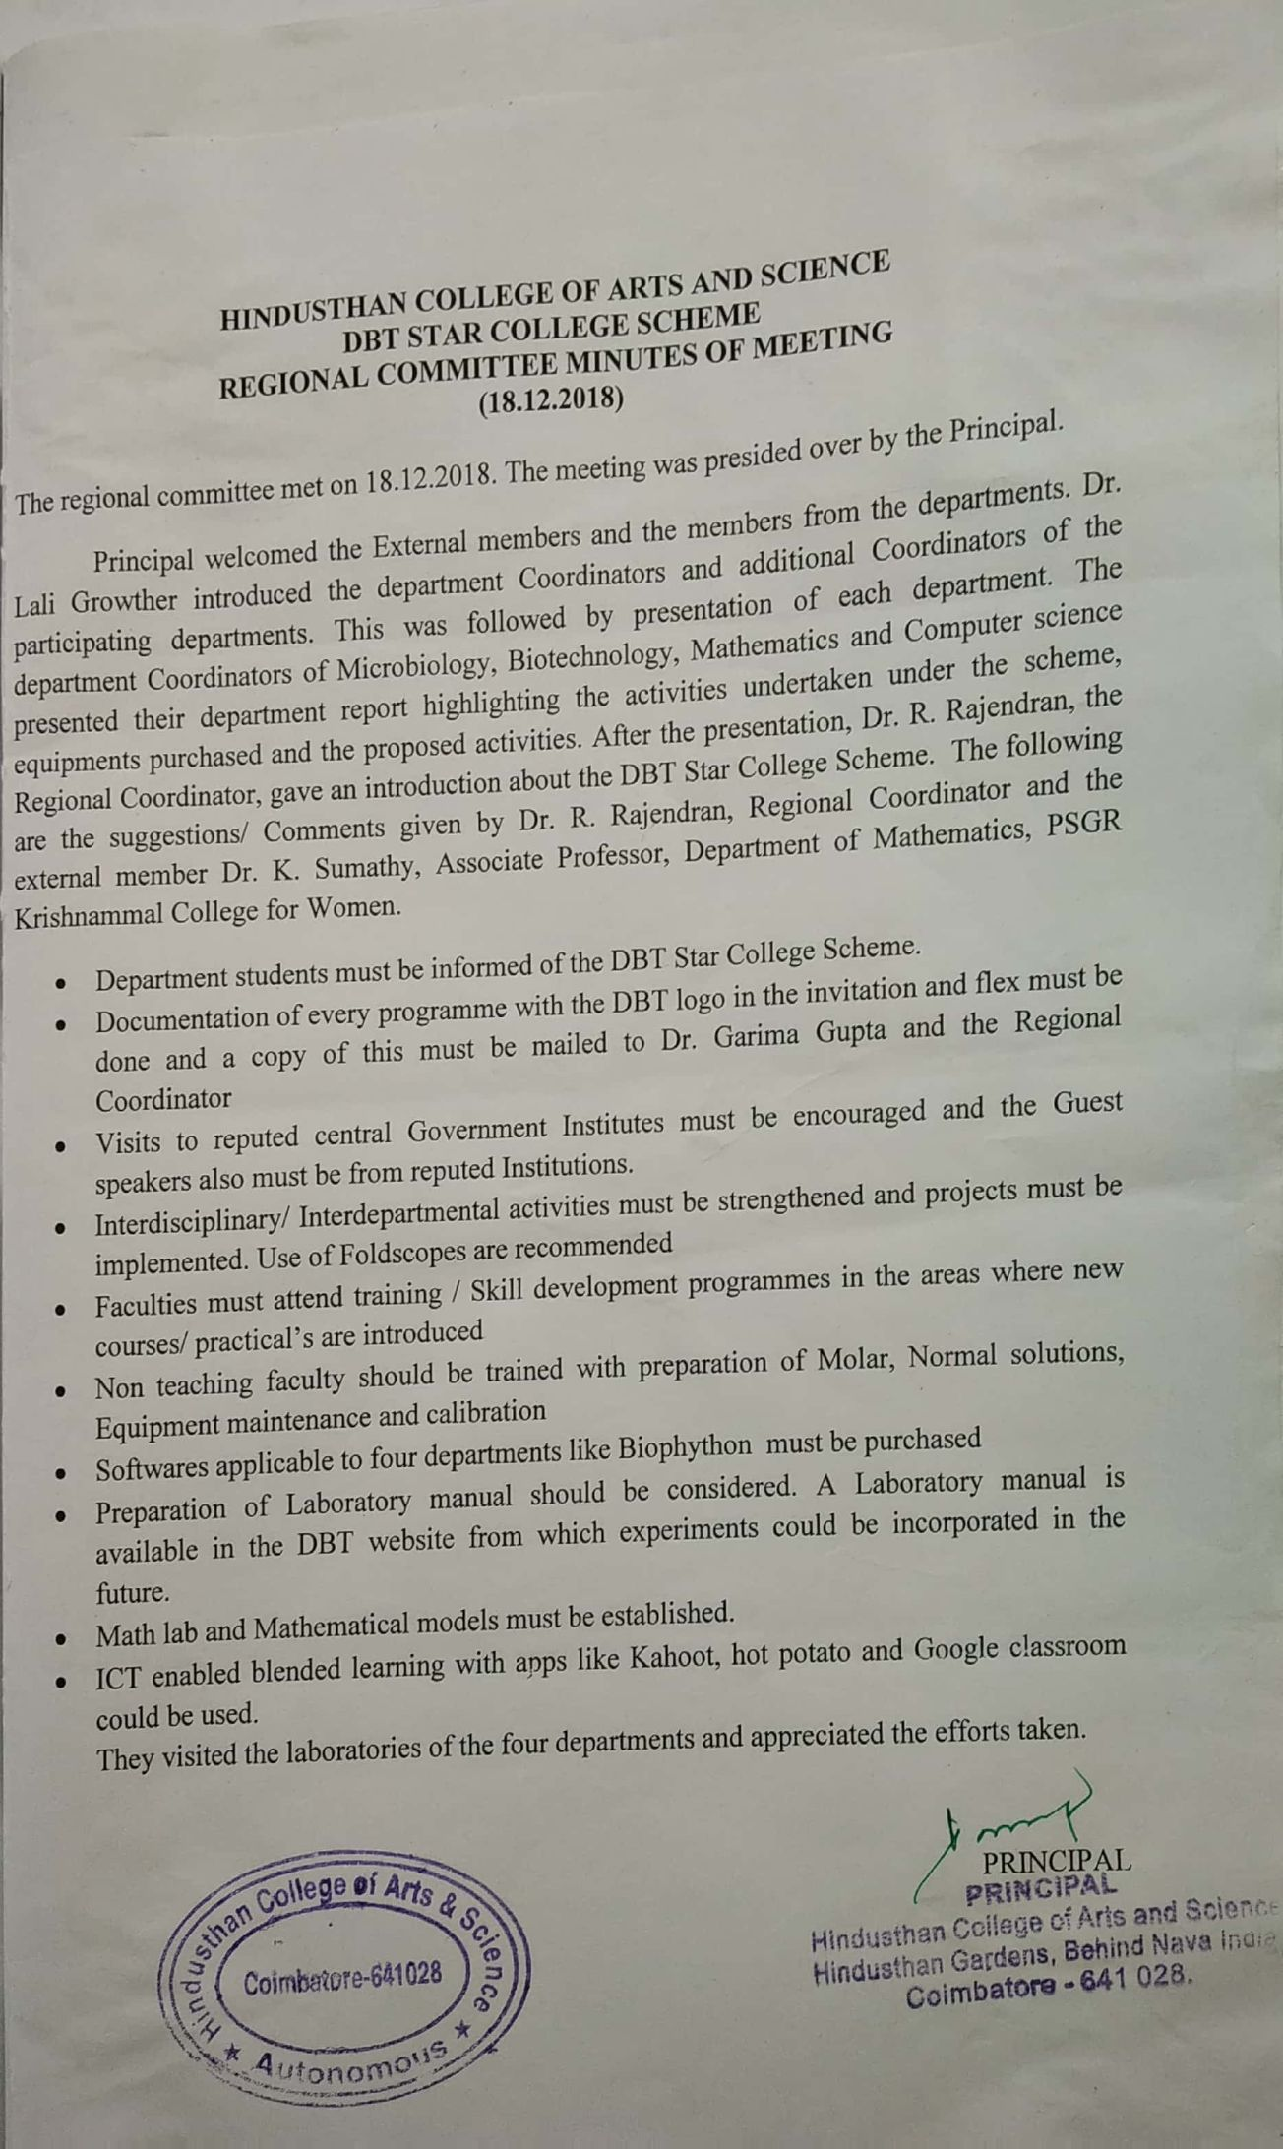
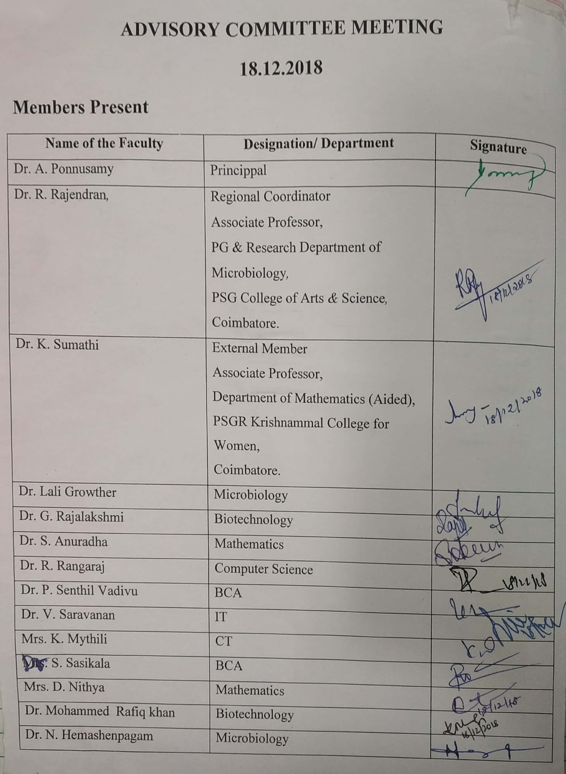
MINUTES OF MEETING HELD ON 29.03.2019
